# Homework: HTML5 Overview

## Hello HTML

Create a HTML document holding the text "Hello HTML". Ensure you have **<doctype>**, **<html>**, **<head>**, **<title>** and **<body>**. Play with the other tags.

## Paragraphs and Images of Text

Create an HTML page holding a few **headings**, each with a few **paragraphs** of text. Insert a few **images**. Play with the old formatting tags **<b>**, **<i>**, **<u>**, **<strong>**, **<em>**, **<sup>**, **<sub>**, **<pre>**, **<br />** etc. Ensure you have **<doctype>**, **<html>**, **<head>**, **<title>** and **<body>**.

## Runners Home

Write an HTML page like the image below (use headings, **<div>**, paragraphs and **<ul>**):

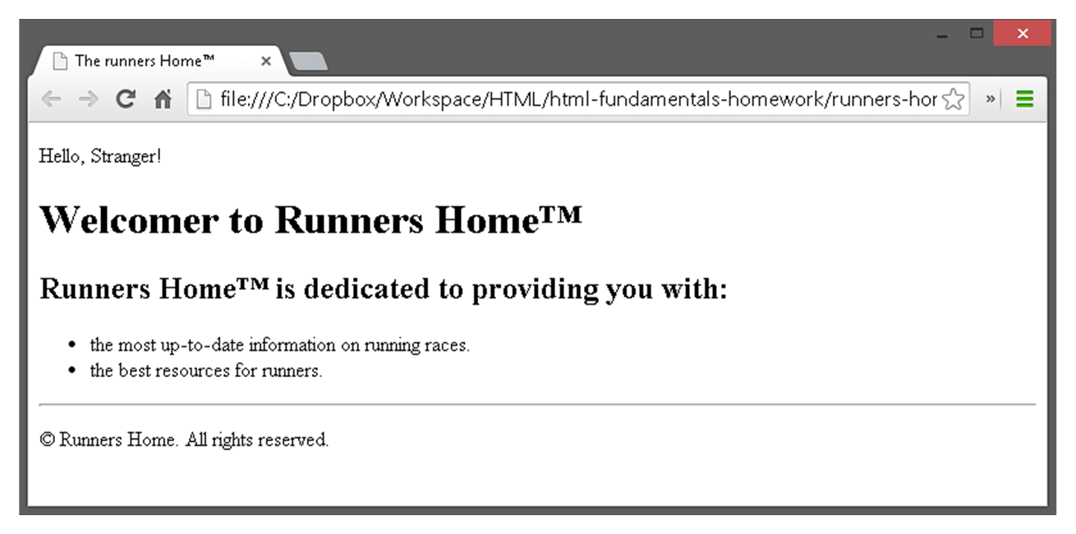

## HTML Lists

Create a HTML page that holds **nested lists** like the example on the below (without the border and the rounded corners). Use **<ol>**, **<ul>** and **<li>**.

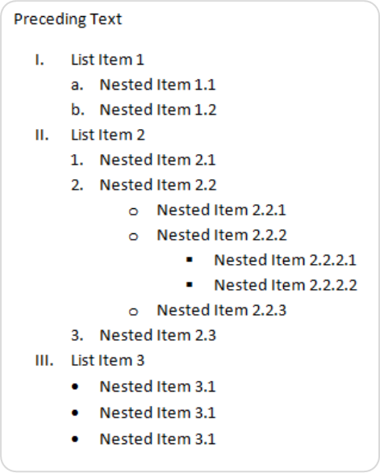

## User Profile Pages

Create user profile Web pages named **profile.html**, friends page named **friends.html** and info page named **home.html**. Link them to one another using **<a href="…">** tag. The pages should look like the following:

